Aristos Athens
ME 182
Model S Analysis Assignment

TP plots at the very end.
Using the following code I find the Model S can go 432 km on a single charge. Important values I use are a 85 kWh battery with 375V and an internal resistance of 1 Ohm.

Questions 1
Problem Statement 1
Assumptions 1
Constants 2
Data 3
Analysis 3
Plots 5
Test Point Plots 10
%Model S Analysis Assignment
%ME 182
%Aristos Athens
close all
clear all

Questions
%Exactly what are the key points and what is needed at each?(TP1, TP2, TP3, TP4)
%Is my value for k ok?
%How do I account for battery capacity changing with discharge rate? What
%Voltage vs Capacity graph/equation to use?

Problem Statement
% In one of our lectures on Slow Dynamics, we analyzes the range that a car can travel given that
% the velocity is specified by repeats of the Simplified Federal Urban Driving Schedule (SFUDS).
% Recall that the lecture was based on EV-1 from General Motors.
% Please replicate the analysis for the Tesla Model S. Plot the waveforms for the key test points
% identified in lecture (TP1, TP2, TP3 and TP4). You will need to find some of the key parameters on
% the internet. Intelligent guesses are also allowed for parameters that are not in the public domain
% provided they are accompanied by a good rationale.
% Determine the distance that the Model S can travel over road that is well modeled as repeats of the SFUDS.
% Assume that the Model S begins with a full battery.
% Hint: Use MatLab or any of the other nice mathematical software packages to complete this assignment.

Assumptions
%2 passengers, each weighing 80 kg.
%Passenger energy use (Photel) is 0.1 times the size of Pte.
%Model discharge graph as linear. i.e. Voltage out vs. discharge declines
%linearly
%

Constants
%General
g = 9.81; %m/sec^2
%Textbook
C_D = 0.24;
A = 2.4; %m^2
mu = 0.005;
massCar = 2108; %kg
etaGears = 0.95;
etaMotor = 0.9;
eta = etaMotor*etaGears;
%Assumptions
passengers = 2;
passengerMass = 80; %kg
massPassengers = passengers*passengerMass;
mass = massCar + massPassengers;
%Flat road
psi = 0; %rad
%Researched
%Using an 85 kWh rated battery
%http://www.roperld.com/science/teslamodels.htm
%http://www.fueleconomy.gov/feg/PowerSearch.do?action=noform&year1=2016&year2=2016&cbmkTesla=Tesla&minmsrpsel=0&maxmsrpsel=0&city=0&hwy=0&comb=0&YearSel=2016&make=Tesla&mclass=&vfuel=&vtype=&trany=&drive=&cyl=&MpgSel=000&sortBy=Make&Units=&url=SearchServlet&opt=new&minmsrp=0&maxmsrp=0&minmpg=&maxmpg=&rowLimit=25&tabView=0&pageno=1
%However, research shows you really have about 81 kWh usable
%https://electrek.co/2016/02/03/tesla-battery-tear-down-85-kwh/
%https://electrek.co/2016/12/14/tesla-battery-capacity/
%Battery energy at full charge
Cbat = 81; %kWh
Cbat = 1000*Cbat; %Wh
%Battery rated voltage
Voc = 375; %V
%Battery internal resistance
Rin = 1; %Ohms
%Peukert's constant for battery recharging
k = 1.12;

Data
data = importdata('SFUDS_Data.mat');

Analysis
%data
v = data(:,2); %km/hour
figure
plot(v)
v = (1/3600)*(1000)*v; %m/sec
v = repmat(v,10000,1); %m/sec
time = transpose(1:1:length(v)); %sec
%Take approximate derivative of velocity to find approximate acceleration
a = diff(v(:));
%Adjust a vector length
a = [0;a];
%Initialize for the loop
FteVec = [];
PVec = [];
PMotorVec = [];
PBatVec = [];
PteVec = [];
QVec = [];
VVec = [];
iVec = [];
dVec = [];
Qoc = Cbat/Voc; %Amp/hr
Q = Qoc; %Amp/hr
V = Voc; %V
t = 0; %time index
d = 0; %m
while (Q > 0)
%time step
t = t + 1;
%Instantaneous load force
Fte = mass*g*(mu + psi + (1.05*a(t))/g) + 0.626*A*C_D*(v(t)^2); %N
%Instantaneous load power draw
Pte = Fte*v(t); %Watt
%Power Hotel
Photel = 0.1*Pte;
%Instantaneous battery current
%Initialize variables
% Pbat1=0;
% Pbat=0;
if (Pte == 0)
i = 0;
Pbat1 = 0;
Pbat = 0;
elseif (Pte > 0)
%Instantaneous power drawn from battery
Pbat1 = Pte/eta + Photel;
Pbat = (1/0.75)*Pbat1;
%discharging battery (consuming energy)
i = (V - sqrt((V^2) - 4*Rin*Pbat)) / (2*Rin); %Amp
else
%Instantaneous power drawn from battery
Pbat1 = eta*Pte + Photel;
Pbat = (1/0.75)*Pbat1;
%charging battery
i = (-V + sqrt((V^2) - 8*Rin*Pbat)) / (4*Rin); %Amp
end
%Instantaneous battery charge
if(Pte > 0)
Q = Q - i/3600; %Amp/hr
else
Q = Q + (i^k)/3600;
end
%Use equation from book to find distance
% if(v(t) ~= 0)
% Photel = 0.1*Fte*v(t);
% deltad = Q*v(t) / ((Fte*v(t)/eta) + Photel);
% if(deltad > 0)
% d = d + deltad;
% end
% end
%Total distance travelled. v is in 1 second increments
d = d + v(t);
%https://endless-sphere.com/forums/viewtopic.php?f=14&t=67721
dischargeSlope = (3.5/3.8 - 1);
discharge = 1 - (Q/Qoc);
V = Voc*(1 + discharge*dischargeSlope);
%Storage arrays
FteVec(t) = Fte;
PVec(t) = Pte;
VVec(t) = V;
QVec(t) = Q;
iVec(t) = i;
dVec(t) = d;
PbatVec(t) = Pbat;
PMotorVec(t) = Pbat1;
PteVec(t) = Pte;
end
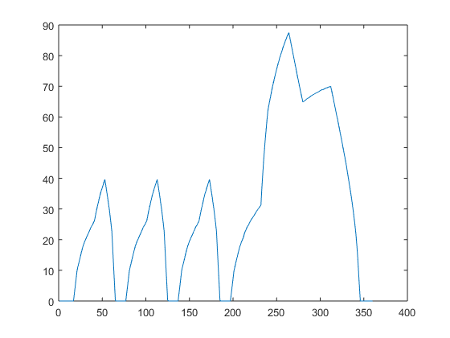

Plots
figure
plot(time,v);
title('Data - Velocity vs Time');
xlabel('time(s)');
ylabel('velocity(m/s)');
figure
plot(time,a);
title('Data - Acceleration vs Time');
xlabel('time(s)');
ylabel('acceleration(m/s^2)');
figure
plot(time(1:length(dVec)),dVec);
title('Calculated - Distance vs Time');
xlabel('time(s)');
ylabel('Distance(m)');
figure
plot(time(1:length(FteVec)),FteVec);
title('Calculated - Fte vs Time');
xlabel('time(s)');
ylabel('Force(N)');
figure
plot(time(1:length(QVec)),QVec);
title('Calculated - Q vs Time');
xlabel('time(s)');
ylabel('Charge(Amp hour)');
figure
plot(time(1:length(iVec)),iVec);
title('Calculated - Battery Current vs Time');
xlabel('time(s)');
ylabel('Current(Amp)');
figure
plot(time(1:length(VVec)),VVec);
title('Calculated - V vs Time');
xlabel('time(s)');
ylabel('Voltage(V)');

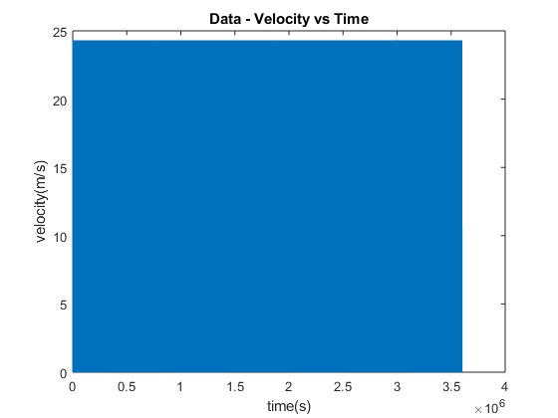
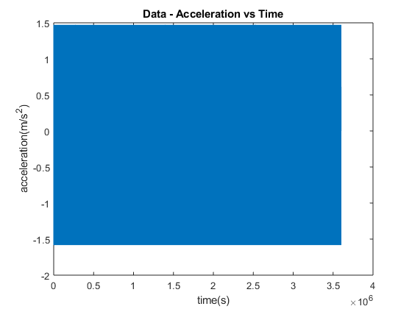
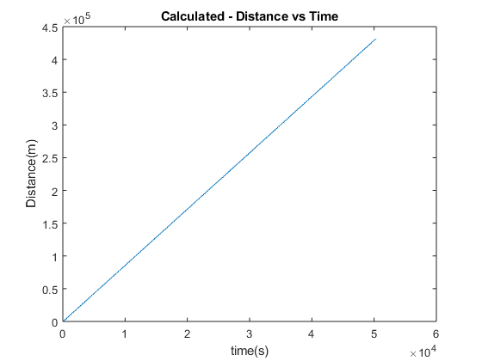
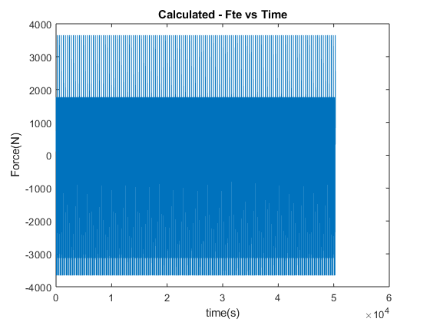
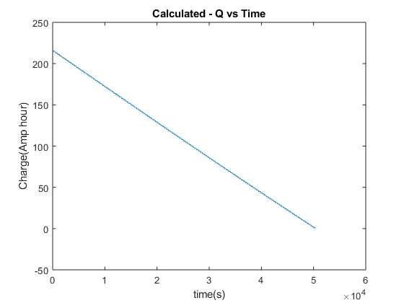
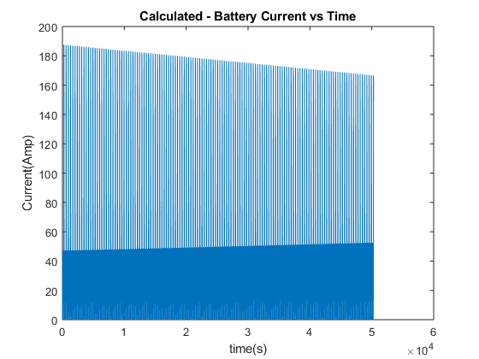
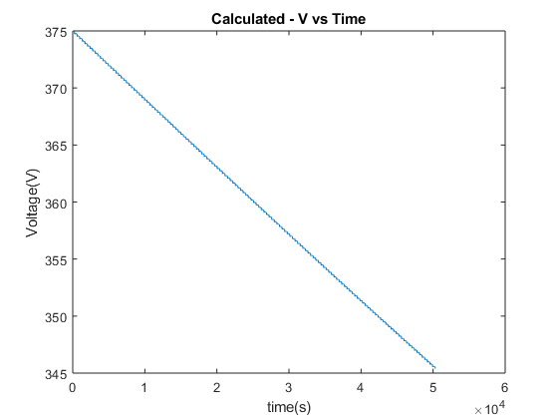

Test Point Plots
figure
plot(time(1:length(data)), v(1:length(data)), time(1:length(data)), a(1:length(data)));
title('TP1 - V and A vs Time');
xlabel('time(s)');
ylabel('Velocity(m/sec), Acceleration(m/sec^2');
figure
plot(time(1:length(data)), PteVec(1:length(data)));
title('TP2 - Power to Move Car');
xlabel('time(s)');
ylabel('Power(W)');
figure
plot(time(1:length(data)), PMotorVec(1:length(data)));
title('TP3 - Power From Motor');
xlabel('time(s)');
ylabel('Power(W)');
figure
plot(time(1:length(data)), PbatVec(1:length(data)));
title('TP4 - Power From Battery');
xlabel('time(s)');
ylabel('Power(W)');
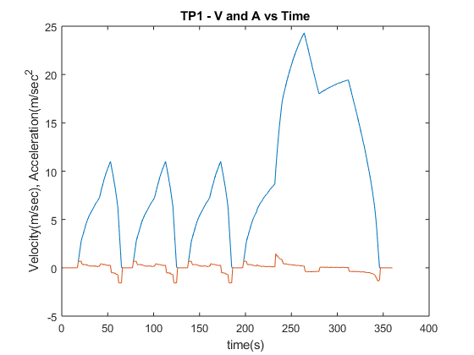
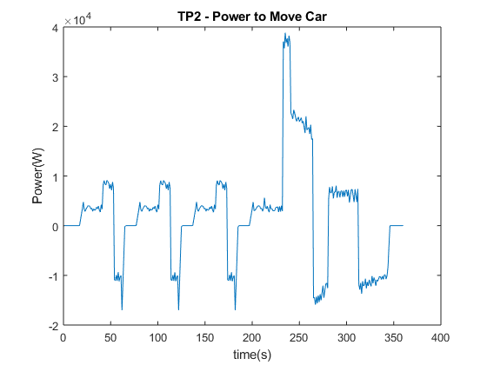
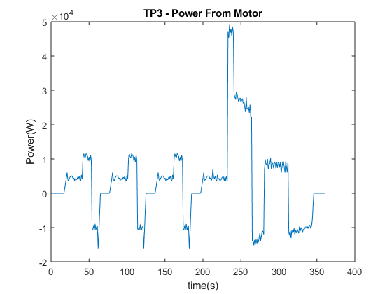
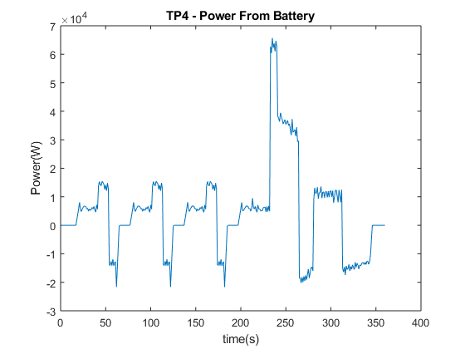
Published with MATLAB® R2017b

